HL Valentine L’Argent
Jason Crislip
Jason.crislip@att.net
Rapier Provost to Master Sebastien de Caen
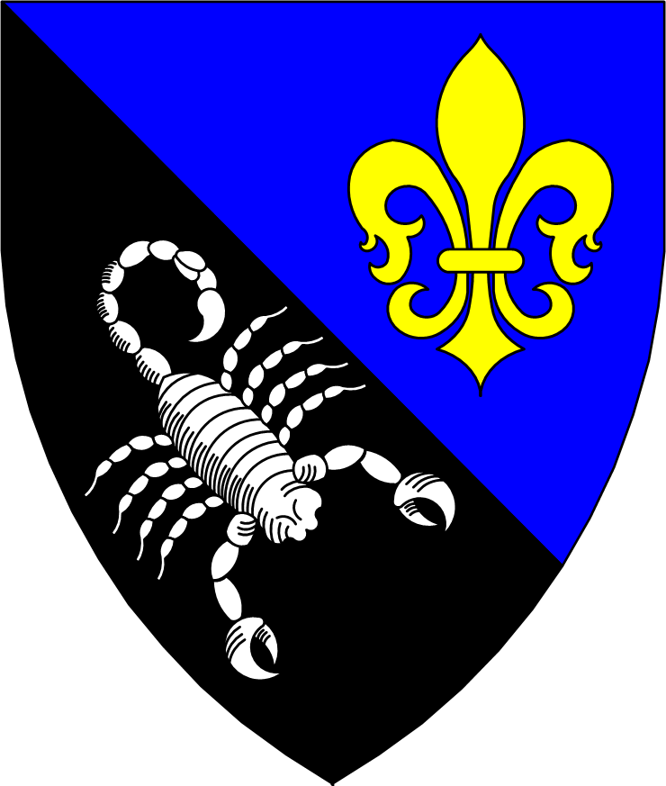
Per bend azure and sable, a fleur-de-lys Or and a scorpion bendwise inverted argent

Valentine L’Argent: After attending several demos and at the invitation of friends to events, I started in 2008 being involved with the SCA (between military obligations) in Calafia, Caid I started attending their fighter practice and beginning my path into Rapier. When I moved to Glymm Mere in 2011, I was actively looking to join the populace and become involved in the Barony. Between trips overseas for my mundane occupation, I attended as many of the fighter practices, events, and meetings as I could. During that time I took on the office of Rapier Marshal in the incipient Canton of Caladphort. During the same period I became much more involved in helping the Barony of Glymm Mere. When the Baronial Master of Stables had to unexpectedly leave office, I stepped up mostly blind to make sure that martial activities could still be carried on. I regularly bring my training and experience as a military martial arts instructor and educator to help new fighters join our combat sports. I find ways to help others at every event that I attend; as a field marshal, helping in camps, cleaning sites, and watching for potential hazards. I use my teamwork skills from many years of experience being a sergeant and supervisor to organize and multiply the value of volunteers on hand. Working with the Kingdom officers and my wife, we were recently able to host a Cut and Thrust class and authorization day. This event let us jump start a Cut and Thrust program in Glymm Mere with several new fighters and marshals. I am qualified in Rapier as senior marshal and in C&T as junior, and in both to fight. I look forward to adding more authorizations to continue to support the various communities.
Offices:
- Rapier Officer (Caladphort) 2019-2020
- Master of Stables (Glymm Mere) 2020-present

Events:
- Teardown crew Crows Feast (Crows Gate/Fire Mountain Keep) 2023
- Panelist Rose and Thorn Symposium (Caladphort) 2023
- Teardown crew Rose and Thorn (Glymm Mere) 2022, 2023
- Field Marshal Junefaire (Dragon’s Laire) 2023
- Setup/teardown crew Kingdom Arts and Sciences and Queen’s Rapier Championship 2023
- Setup/teardown crew Yule (Glymm Mere) 2018, 2019, 2021, 2022
- Assisted in teardown for Baronial camp Autumn War 2022, Junefaire 2022
- Setup/teardown crew Mayfaire (Glymm Mere) 2019, 2022
- Assisted in teardown for Kingdom Arts and Sciences and Queen’s Rapier Championship 2022
- Silent auction delivery Yule (held online) (Glymm Mere) 2020
- Assisted with many demos in Caladphort and Glymm Mere

Awards:
- Baron’s favor (Glymm Mere) Oct 2023
- Goutte de Sang (An Tir) Dec 2022
- Ewer (Glymm Mere) Oct 2022
- Baroness' favor (Glymm Mere) Aug 2022
- Rapier Champion (Glymm Mere) 2022-present (second term by request of B&B Glymm Mere)
- Award of Arms (An Tir) Jan 2022
- Glimmering Gauntlet (Glymm Mere) Dec 2021
- Crystal (Glymm Mere) Sep 2020

Current projects:
- I am teaching myself French to further my persona
- Teaching myself to play the bodhran (with some expert bardic advice)
- Launching a Baronial Cut and Thrust program, including recently getting my own authorization to fight and marshal to better foster and support a community
- Slowly learning to make armor and equipment to support all fighting activities
- At 2 practices every week, teaching and coaching newer fighters in SCA Rapier
- Continually reading and learning to improve my ability to teach Rapier, both from historical texts and modern sport and teaching theory from experts

