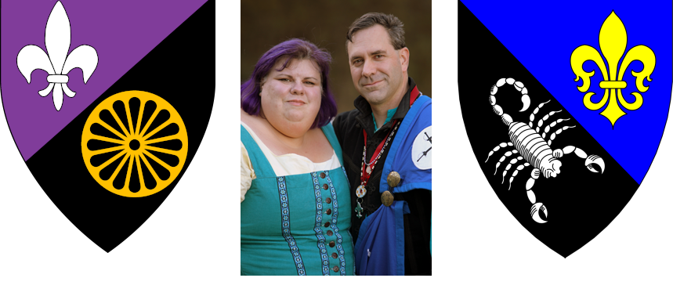

Joyous Greetings Unto Their Majesties, Their Highnesses, The Seneschal of An Tir, Their Excellencies of Glymm Mere, The Seneschals of Caladphort and Crow’s Gate (Firemountain Keep), and the Populace of Glymm Mere and her territories,
With much excitement, we, HL Tamsyn l’Argent and HL Valentine l’Argent do most humbly make known our desire to be considered as Baroness and Baron in service to Glymm Mere. We have both been active for many years in the SCA, finding friends, family, and great joy; we would like to take this opportunity to give back to the Society and Barony that have given us so much for so long.
During our time as officers of the Canton of Caladphort, we hosted A&S days, classes, fighter practices, parties, and potlucks at our home to help build the friendship and familiarity amongst the populace. While officers of Glymm Mere we have been thrilled to be part of the growth of a sense of community during the reign of Their Excellencies Disa and Alasdair. We both look forward to the opportunity to continue as active stewards to that expanding culture. We appreciate so many aspects of the SCA, even those we are not active in, and we would encourage others to explore all that the SCA has to offer. A greater understanding between focused groups leads to appreciation and maybe even new passions.
In our offices we have always endeavored to be available to the populace as much as possible and will continue that effort. We have both been dedicated to being responsive, helpful, and above all safe people to come to with questions, concerns, or assistance navigating situations. We are both passionate about DEIB in the society and have been blessed to have been part of the team for Rose and Thorn Symposium since its inception. It is an event we will continue to support to our utmost abilities until such time as those it represents look at it and ask, “Why do we need this event?” Then it will have succeeded.
We would both like to see people become reinvested in the Sargentry of the barony as it is a tradition so unique to An Tir. Our rich history and traditions should be showcased and celebrated. At the same time, we understand and encourage positive evolution and growth. There is absolutely room for both older and newer ideas and listening to both should be encouraged.
Both of us worked hard as founding members of the Canton of Caladphort for recognition not just as a branch, but for recognition of the many fine qualities that the people here bring to the barony and society. Should we be selected, we would make sure that those in the far-flung areas of Glymm Mere feel represented and supported by their coronets. Activities that are as accessible as possible for all three are absolutely a goal. Tamsyn has been very diligent in making sure that educational opportunities for officers are shared to the entire region. We want to facilitate a baronial encampment at events we are attending to ensure that members of the populace who don’t have a household know that they will have a place where they are welcome.
In this position we recognize that all of our words and deeds will have a greater impact and further reach than anything we have dealt with before, so we will both place great effort into polishing our interactions to best represent the barony and kingdom. It is not unlike going from stage crew to center stage and that will be a change of point of view. We know we are up to the challenge but we do understand that it is a challenge.
We greatly look forward to an opportunity to work with our neighboring baronies as well. Tamsyn has been on event teams for kingdom events, and we have both volunteered at events in our surrounding baronies where we have made friends and learned more about the unique culture of each branch. It is always a joy to share that with others. Being Baroness and Baron would give us more opportunities to do so and to build lasting relationships with other branches.
In recent years we’ve seen success with our demos and we will be actively continuing to support them. We also believe that rebuilding ties with our local colleges would provide opportunities to bring the SCA to the attention of potential members. Tamsyn has been working within her office of seneschal to help restart youth programs including youth armored combat and making sure event budgets have a byline for youth activities to make us more welcoming to families as an organization.
For us, the SCA is family and Glymm Mere is home. We love this barony and its people and want to see it not just live but thrive. As baroness and baron we believe that we would be in a better position to encourage that. We would be in a more visible position to lead by example. We would have a greater platform to share our love for all the society and barony are.
Thank you for your consideration.
Yours In Service,
HL Tamsyn l’Argent
HL Valentine l’Argent

